NPRB 2301: Pacific Sleeper Shark Ageing

# Meeting Information

PSS Ageing Project Planning Meeting

Thursday, July 13 · 8:00 – 9:00am

Time zone: America/Anchorage

Google Meet joining info

Video call link: https://meet.google.com/hnc-gjmh-wsa

Or dial: ‪(US) +1 605-865-2088‬ PIN: ‪601 637 759‬#

More phone numbers: https://tel.meet/hnc-gjmh-wsa?pin=6791962608157

# Attendees

Bruce, Dan, Beth, Cindy, Taylor

# Overview

(OMG….we made it, now we have to do something)

# NPRB/Budget Check In

Some revised budgets, but nearly all have been returned

May have a delay in NPRB releasing funds, but not by much

# Platforms

Can everyone access Gsuite?

Alternative suggestions: AFSC Public Dropbox (Cindy will make sure all data are non-confidential)

* Cindy will talk to IT for other options Gsuite not going to work
* Cindy will explore using GitHub as venue for sharing docs, analytics and project management

# Timeline

Do we want monthly check-ins? At least for starters, then reassess. Late Sept or early Oct (Monday AM bad) Will send another doodle

When to do first PI meeting - Plan for January

Important Dates

| 1 Sept 2023 | Soft start date |
| --- | --- |
| Jan | PI meeting Sacramento |
| 1 Feb 2024 | Progress report due |
| 1 Sept 2024 | Progress report due |
| 1 Feb 2025 | Progress report due |
| 1 Sept 2025 | Progress report due |
|  | PI meeting Seattle |
| Jan 2026 | AMSS planned attendance |
| 31 Jan 2026 | Project end date - no extensions, spend all funds before this date |
| 28 Feb 2026 | Final report due |
|  |  |
|  |  |

## Phase 1: inventory samples - Cindy is working on it right now

* 162 total PSS eyes or sets of eyes in hand (total animals)
* 77 PSS animals with complete information (55, with both eyes) - information still being recovered from at-sea observer files
* Lots of error checking being done on at-sea observer data
  + Check if observer recorded TL instead of PCL
  + Conversions from standard to metric
  + Filter actual weight data from table or other estimates (if we want weight)
* Currently expect about 50 more PSS samples to come in over the 2023 fishing season, already have the data in hand for 12 of them
* Dist of samples by animal size, in cm (note: sizes are raw data, error checks still need to be performed and sizes translated to consistent lengths)

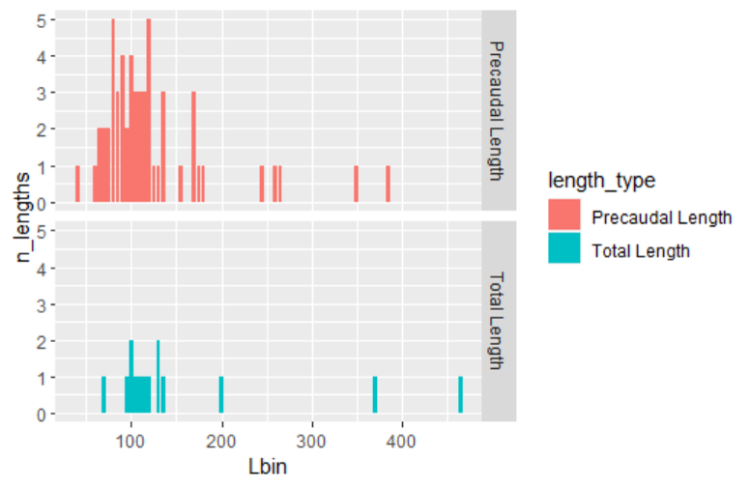

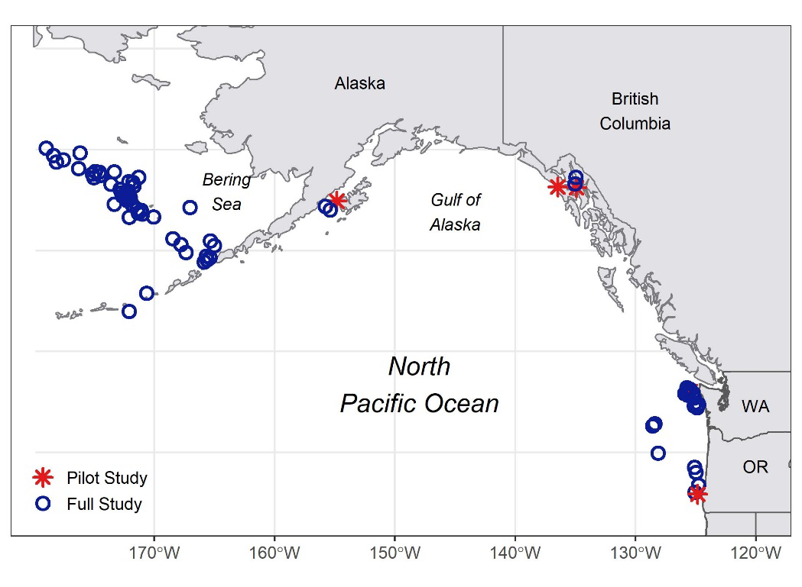

* 25 spiny dogfish “large” females in hand with data, many with embryos (still getting them inventoried), more to be collected this summer

## Phase 2: select samples, separate layers and prep for AMS/isotopes

Below is the table from the proposal with our desired sample sizes. Budgeted for 240 AMS (both PSS and SD), 40 bulk isotopes and 5 CSIA (SD only).

Total of 30 PSS animals to be sampled, 10 SD

What do we pick? Size range, maturity info, sexes distribution?

Does area matter?

How many extra eyes should we prep?

Are isotopes from same eyes we do AMS on, or do we need to prep more eyes?

* Prioritize eye pairs from sleeper sharks
* Plan for goopy eyes, select extras
* Practice eyes - start with 5-10
* Even size distribution of samples
* Still need to discuss if basins matter, likely these animals are semi-resident due to ontogentic minimal movement
* Ship practice eyes to Dan Sept 1

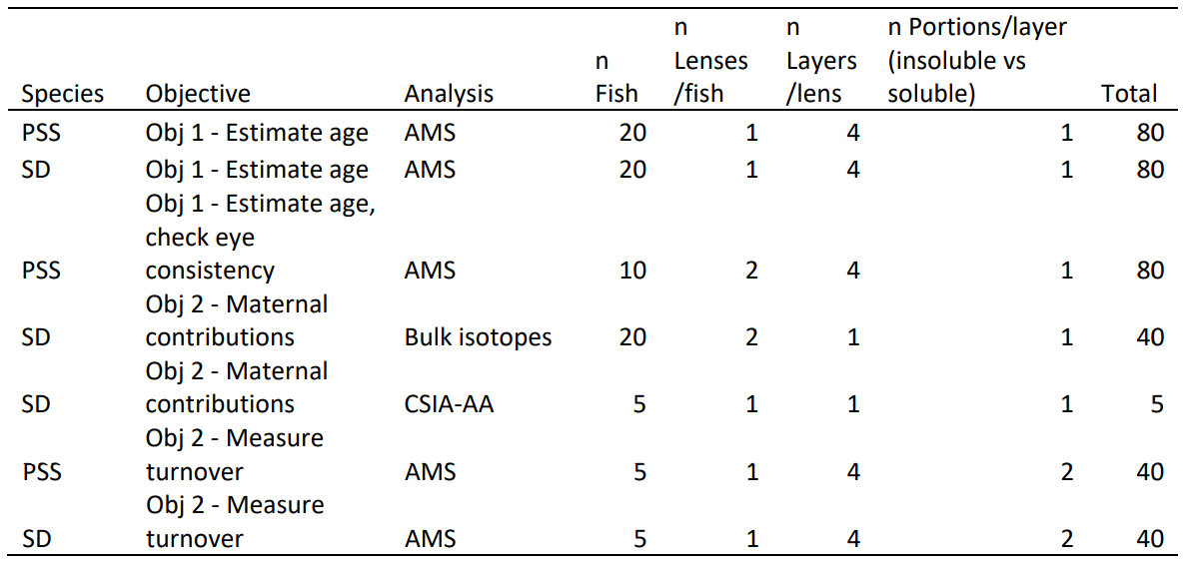

# Action items

* [Cindy Tribuzio - NOAA Federal](mailto:cindy.tribuzio@noaa.gov) Follow-up with NPRB re LLNL documents. LLNL hasn’t received a response, so not sure where things got lost.
* [Cindy Tribuzio - NOAA Federal](mailto:cindy.tribuzio@noaa.gov) Set up collaboration environment (can’t use GSuite): maybe GitHub? Provides reproducible code platform, but also shared docs and project management tools
* [Cindy Tribuzio - NOAA Federal](mailto:cindy.tribuzio@noaa.gov) Complete freezer inventory and database creation. Includes finding missing observer data forms, creating non-confidential haul locations, identifying practice specimens
* [Cindy Tribuzio - NOAA Federal](mailto:cindy.tribuzio@noaa.gov) Set up sample discussion meeting late Aug
* [Cindy Tribuzio - NOAA Federal](mailto:cindy.tribuzio@noaa.gov) Ship practice samples to Dan
* [dnstewart.ucdavis@gmail.com](mailto:dnstewart.ucdavis@gmail.com) Prepare to receive samples about Sept 1 and conduct practice dissections to evaluate condition and refine techniques

# 